|  |  |
| --- | --- |
|  | **الرقــم :1**  **التاريــــــخ :2**  **المرفقــات :4** |

|  |  |  |  |
| --- | --- | --- | --- |
| 23 |  |  |  |

|  |  |  |  |
| --- | --- | --- | --- |
|  |  |  |  |

|  |  |  |  |  |
| --- | --- | --- | --- | --- |
| 1234343434343434343434 | 1234 | 1234 | 123`123 | 446456 |
| 123123 | 123123 | 123123 |  |  |
| 223e |  |  |  | 12321 |



|  |  |  |  |
| --- | --- | --- | --- |
| 23123123 | 2312 | 123 | 123123 |

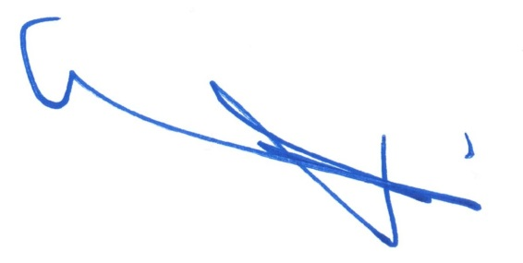أمين منطقة الرياض

إبراهيم بن محمد السلطان